**IFT 166 Introduction to Internet Networking**

**Lab 11**

**Spot the difference**

**After you complete each step, put a ‘√’ or ‘x’ in the completed box   
or**

**Provide answers to the 4 open questions**

**Objective**

By comparing the configurations in two topologies, find the configuration errors in Topology B.

1. In packet tracer, open the file “Spot the difference I” (located in the modules sections below this lab).   
     
   You should see the following 2 topologies.

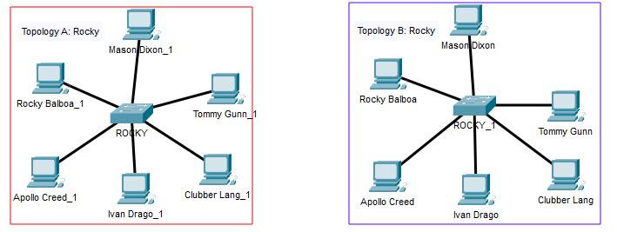



1. All PCs can ping each other in Topology A.

All the PCs in Topology B should be able to ping each other. This is the not the case.  
  
There are 4 configuration differences in the 2 topologies (the 4 incorrect configurations are on Topology B)

**Spot the 4 differences.**

1. List each difference and why it needs to be corrected to allow the communications.



Mason_Dixon_1 IP Address on Topology 2 IP address is 192.168.2.2

The rest of the network has a network address of 192.168.1/24



Ivan Drago on Topology 2 has a different subnet mask /28

In order for networks to communicate with each other, then need to be on the same subnet mask



Clubber_Lang_1 had the wrong IP address 192.186.1.4

Networks need to share the same IP address



Fastethernet 0/2 from the switch, which is connected to Rocky balboa, was not turned on.

The Switch port needs to be turned on for the switch to function.